Integrating Safety Information into the System Engineering Process

Nancy G. Leveson, Ph.D.; Massachusetts Institute of Technology, Cambridge, MA

Abstract

One of the most important jobs of the system safety engineer is to document safety-related information in such a way that it can be traced throughout system development. Such information must be in a form that can be used by system engineers when they are making critical decisions. Often, the system safety engineers are busy producing their own documentation while the system engineers are designing the system. By the time the system engineers get the information created by the system safety engineers, it is too late to have the impact on design decisions that are necessary to be most effective.

This paper describes a way to integrate basic system development with system safety engineering in such a way that information is available to designers when needed in the development process and in a form that can have a maximal impact on design and validation activities. Complete traceability of safety activities from high-level system requirements down to detailed design is another result of the approach. Traceability is critical for verification and validation of system safety as well as reanalyzing safety when changes are proposed or occur.

Introduction

The quality of the safety information system is one of the most important factors distinguishing between safe and unsafe companies when matched on other variables (ref. 1). Although setting up a comprehensive and usable information system can be time consuming and costly, such a system is crucial to the success of safety efforts. Too often, system safety engineers are busy creating safety analyses while the system engineers are making critical decisions about system design and concept of operations that are not based on hazard analysis. If and when they get the results of the system safety activities, often in the form of a critique of the design late in the development process, it is frequently ignored or argued away because changing the design at that time is too costly.

Good decision-making requires information. Documenting and tracking hazards and their resolution are basic requirements for any effective safety program. But simply having the safety engineer track them is not enough⎯they need to be specified and recorded in a way that has an impact on the decisions made during system design and operations. To have such an impact, the safety-related information required by the engineers needs to be integrated into the environment in which safety-related decisions are made. Engineers are unlikely to be able to read through volumes of hazard analysis information and relate it easily to the specific component upon which they are working. If the information the system safety engineer has painfully generated is not presented to the system designers, implementers, maintainers, and operators in a way that they can easily find it when they need to make decisions, risk is increased.

Information also needs to be presented in a form that people can learn from, apply to their daily jobs, and use throughout the life cycle of projects, not just in the conceptual design stage. Too often, preventable accidents have occurred due to changes that were made after the initial design period. Accidents are often the result of safety-related decisions that were originally correct but were changed by default when operations changed, or they are due to insufficient updates to the hazard analysis when engineering modifications were made. These factors are most important in complex, software-intensive systems where nobody is able to keep all the information necessary to make safe decisions in their head.

SpecTRM (Specification Tools and Requirements Methodology) is a requirements and system specification environment designed to integrate the results of system safety activities into the mainstream engineering specifications. It provides both a suite of sophisticated system engineering tools that support the design of complex, software-intensive systems and a way to associate the information derived from hazard analyses with engineering decisions and the documentation of design rationale. Safety-related information and decisions can be traced down from the early stages of system concept formation to detailed design and operations.

The basic concept underlying SpecTRM is an intent specification.

Intent Specifications

The design of intent specifications is based on research about how experts solve problems and how best to support this problem-solving process as well as on basic principles of system engineering. An intent specification differs from a standard specification primarily in its structure, not its content: the specification is structured as a hierarchy of models designed to describe the system from different viewpoints, with complete traceability between the models. This structure was designed (1) to facilitate the tracing of system-level requirements and design constraints to detailed design and implementation (and vice versa); (2) to assist in the assurance of various system properties, including safety; and (3) to reduce the costs of implementing changes and of revalidating correctness and safety when the system is changed, as it inevitably will be.

No extra specification is involved (unless current specification practices are deficient), but simply organizing the information in a way that has been found to be the most helpful in using the information that is specified. Most complex systems have voluminous documentation, much of it redundant or inconsistent, and sometimes missing important information, particularly information about why something was done the way it was⎯the intent. Documentation is almost always out of date, particularly as changes start to be made during operations. Trying to determine whether a change might have a negative impact on safety, if possible at all, is usually enormously expensive and often involves regenerating analyses and work that was already done but either not recorded or not easily located when needed. Intent specifications were designed to help with these problems.

Intent specifications have seven levels (see Figure 1). Levels do not represent refinement, as in other more common hierarchical specification structures; instead, each level represents a different model of the same system from a different perspective and supports a different type of reasoning about it. Refinement and decomposition occurs within each level of the specification, rather than between levels. Each level provides information not just about what and how, but why, that is, the design rationale and reasons behind the design decisions, including safety considerations.

The top level (Level 0) provides a project management view and insight into the relationship between the plans and the project development status through links to the other parts of the intent specification. The system safety plan would be included here, with the links pointing to the results of the activities included in the plan.

Level 1 is the customer view and assists system engineers and customers in agreeing on what should be built and whether that has been accomplished.

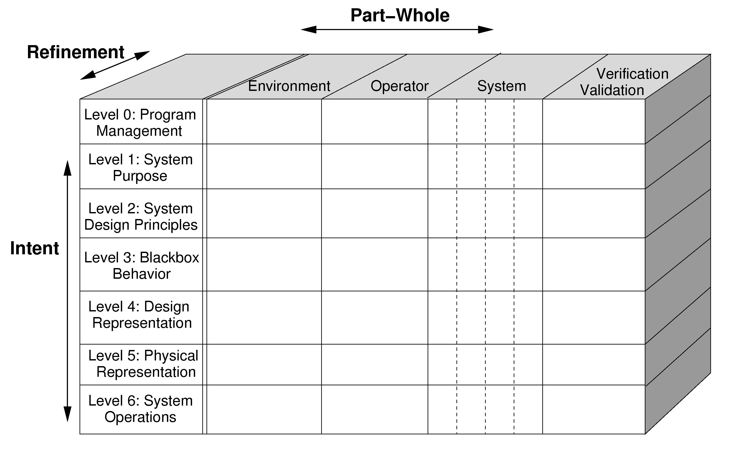

Figure 1 - The General Structure of an Intent Specification.

Level 2 is the system engineering view and helps engineers to record and reason about the system in terms of the physical principles and system-level design principles upon which the system design is based.

Level 3 serves as an unambiguous interface between system engineers and component engineers. At Level 3, the system functions defined at Level 2 are decomposed, allocated to components, and specified rigorously. Black box behavioral component models are used to specify and reason about the logical design of the system as a whole and the interactions among individual system components without being distracted by implementation details. We have found these models to be extremely helpful in engineering reviews, analysis, and simulation. The language used at Level 3, SpecTRM-RL, has a formal foundation so it can be executed and subjected to mathematical analysis. At the same time, the language was designed to be readable with minimal training⎯the models can be read and reviewed after about 10 minutes instruction.

The next two levels (Design Representation and Physical Representation) provide the information necessary to reason about individual component design and implementation issues. Some parts of Level 4 may not be needed if at least portions of the physical design can be generated automatically from the models at Level 3 (as is true for software).

The final level, Operations, provides a view of the operational system and is useful in mapping between the designed system and its underlying assumptions about the operating environment envisioned during design and the actual operating environment. It assists in designing and performing system safety activities during system operations.

Each level contains appropriate information about the environment (the interface specifications), the operators of the system and the human-machine interfaces, and the system itself as well as a specification of the requirements for and results of verification and validation activities of the information included at that level. As shown in the example in the next section, the safety information is embedded in each level (instead of being maintained in a separate safety log) but linked together so it can easily be located.

Hyperlinks are used within and between levels. These mappings provide the relational information that allows reasoning within levels and across levels, including the tracing from high-level requirements down to implementation and vice versa. Note that the structure of the specification does not imply that the development must proceed from the top levels down to the bottom levels in that order, only that at the end of the development process, all levels are complete. Almost all development involves work at all of the levels at the same time.

Intent specifications integrate design rationale and the assumptions upon which the system design and validation is based directly into the specification and its structure. Usually, this information can be found only in the engineers’ memory or it may be captured in special documentation, neither of which is very reliable. Information about design rationale is critical to the success of engineering development and maintenance. When the system changes, the environment in which the system operates changes, or components are reused in a different system, a new or updated safety analysis is required. Assumptions about the operating environment or system design used in the original safety analysis may be included in the safety analysis documentation, but they are not usually traced to the parts of the implementation they affect. Thus, even if the system safety engineer knows that a safety analysis assumption has changed (for example, the original safety analysis for a pacemaker included only adults as potential recipients but the medical environment changes such that they are now being used on children), it is a very difficult and resource-intensive process to figure out which parts of the design were based on that assumption. Intent specifications are designed to make that process feasible.

Example of an Intent Specification

Figure 2 shows an example of what might be included in an intent specification. The specific information needed, of course, will vary with the type and scope of the project, but each level answers the question “why” for the design decisions in the level below.

Management View of the Project: One problem in managing large projects is simply getting visibility into the progress of the project, particularly when a lot of software is involved. The highest level of an intent specification is the project management view. Here one might put project plans, such as risk management plans, pert charts, etc. along with status and pointers to the location of detailed information about each particular aspect. The system safety plan will reside at this level, with embedded pointers to the various parts of the intent specification that implement the parts of the plan, such as the hazard list, various hazard analysis results, etc.

Customer View: Level 1 is the customer's view of the project and includes the ``contractual'' requirements (shall statements) and design constraints. It might contain the system goals, high-level functional requirements, system design constraints (including safety constraints), hazard lists and preliminary hazard analyses (as well as the results of analyses of other system properties) along with pointers to the information that would normally be put into a separate hazard log, assumptions about and constraints on the operating environment, and documentation of system limitations.

Figure 2 - Example Contents of an Intent Specification.

TCAS⎯an airborne collision avoidance system required on most commercial aircraft in this country⎯is used here as an example (ref. 2). Level 1 of our TCAS intent specification includes historical information on previous attempts to build a collision avoidance system and why they were unsuccessful as well as a general introduction to the problem and the approach taken for TCAS. The environment in which TCAS will execute is described, such as the antennas it can use and the systems on the aircraft (such as the transponders) with which TCAS must interact. Assumptions about the environment that the TCAS design depends on include such things as:

EA-1: Altitude information is available from intruders with a minimum precision of 100 feet.
EA-2: All aircraft will have legal identification numbers.

An example of a TCAS functional goal included at Level 1 is:

G-1: Provide affordable and compatible collision avoidance system options for a broad spectrum of National Airspace System users.

A high-level requirement linked to this goal is:

FR-1: TCAS shall provide collision avoidance protection for any two aircraft closing horizontally at any rate up to 1200 knots and vertically up to 10,000 feet per minute.
Assumption: Commercial aircraft can operate up to 600 knots and 5000 fpm during vertical climb or controlled descent and therefore the planes can close horizontally up to 1200 knots and vertically up to 10,000 fpm.

The documentation of the assumption underlying the use of the particular numbers in the requirement means that in the future, when aircraft design might change or there may be proposed changes in airspace management, the origin of the specific numbers in the requirement (1200 and 10,000) can be determined and evaluated for their continued relevance over time. In the absence of the documentation of such assumptions, numbers tend to become “magic” and everyone is afraid to change them.

The hazard list for TCAS is:
- A near midair collision (NMAC), defined as an encounter for which, at the closest point of approach, the vertical separation is less than 500 feet.
- A controlled maneuver into the ground (e.g., a descend command near terrain).
- Loss of control over the aircraft.
- Interference with other safety-related systems (e.g., ground proximity warning).

Level 1 also includes the safety design constraints and requirements that are generated as a result of the identification of hazards. For example, the hazard “Loss of control of the aircraft” leads to the following safety constraint:

SC-5: The system must not disrupt the pilot and ATC operations during critical phases of flight nor disrupt aircraft operation.

SC-5.1: The pilot of a TCAS-equipped aircraft must have the option to switch to the Traffic-Advisory-Only mode where traffic advisories are displayed but display of resolution advisories is prohibited [↓2.37].
Assumption: This feature will be used only during final approach to parallel runways when two aircraft are projected to come close to each other and TCAS would call for an evasive maneuver [↓6.17].

The link to Level 2 (↓2.37) points to the system design features on Level 2 of the intent specification that implements this safety constraint. The specified assumption is critical for evaluating safety during operations. Humans tend to change their behavior over time and use automation in different ways than originally intended by the designers. Sometimes, these new uses can be dangerous. The hyperlink at the end of the assumption (↓6.17) points to the location in Level-6 where auditing procedures for safety during operations are defined.

As another example of a safety constraint, consider the following constraints arising from the first hazard listed above⎯near midair collisions (NMACs):
SC-7: TCAS must not create near misses (result in a hazardous level of vertical separation that would not have occurred had the aircraft not carried TCAS).

SC-7.1: Crossing maneuvers must be avoided if possible [↓2.36, ↓2.38, ↓2.48, ↓2.49.2]

SC-7.2: The reversal of a displayed advisory must be extremely rare [↓2.51, ↓2.56.3, ↓2.65.3, ↓2.66]

SC-7.3: TCAS must not reverse an advisory if the pilot will have insufficient time to respond to the RA before the closest point of approach (four seconds or less) or if own and intruder aircraft are separated by less than 200 feet vertically when ten seconds or less remain to closest point of approach [↓2.52].

The next section of this paper shows, as an example, one of the design features at Level 2 (2.51) used to satisfy design constraint SC-7.2.

Links to requirements and design constraints at Level 1 or to design features at Level 2 may also be embedded in the Level 1 hazard analysis. For example, if fault trees are used, there would be a pointer from each leaf node to the location of the resolution of the hazard⎯to Level 1 functional requirements, to design constraints, to system design features, and to system limitations.

System limitations are also specified at Level 1. They may be simply requirements or environmental constraints that could not be satisfied in the design or they could be related to hazards that could not be fully mitigated. Limitations are specified in Level 1 as they rightly belong in the Customer View of the system⎯they must be accepted by management, regulatory agencies, and system customers. For example, our TCAS intent specification includes the following system limitation related to an unresolvable hazard: “L-5: TCAS provides no protection against aircraft with non-operational or non-Mode C transponders [→FTA-370].” This limitation is linked to the related Level 1 fault tree leaf node (FTA-370) on Level 1 that could not be resolved, and that leaf node would in turn have a link to this limitation.

System Engineering View: Level 2 contains the basic principles upon which the system design depends. It also describes how the Level 1 requirements are achieved, including any ``derived'' requirements and design features not related to the Level 1 requirements, and how the Level 1 design constraints are enforced. It is at this level that the user of the intent specification can get an overview of the system design and determine why the design decisions were made.

The Level 2 design decisions specified here have links to the related Level 1 safety-related design constraints and also pointers to boxes in the Level 1 fault tree to explain why the design feature was included. For example, design principle 2.51 (related to safety constraint SC-7.2 at level 1 shown above) describes how sense reversals are handled:

2.51 Sense Reversals: (↓Reversal-Provides-More-Separation) In most encounter situations, the resolution advisory sense will be maintained for the duration of an encounter with a threat aircraft ↑SC-7.2. However, under certain circumstances, it may be necessary for that sense to be reversed. For example, a conflict between two TCAS-equipped aircraft will, with very high probability, result in selection of complementary advisory senses because of the coordination protocol between the two aircraft. However, if coordination communication between the two aircraft are disrupted at a critical time of sense selection, both aircraft may chose their advisories independently ↑FTA-1300. This could possibly result in selection of incompatible senses ↑FTA-395.
2.51.1 … [information about how incompatibilities are handled]

Design principle 2.51 describes the conditions under which reversals of TCAS advisories can result in incompatible senses and lead to the creation of a hazard by TCAS. The pointer labeled ↑FTA-395 is to a box in the TCAS fault tree for the near-miss hazard that includes that problem. The fault tree box ↑FTA-395 in Level 1 would have a complementary pointer to section 2.51 in Level 2. The design decisions made to handle such incompatibilities are described in 2.51.1 but that part of the specification is omitted here. 2.51 also contains a hyperlink (↓Reversal-Provides-More-Separation) to the detailed Level 3 logic used to implement the design principle.

Information about the allocation of these design decisions to individual system components and the logic involved is located in Level 3, which in turn has links to the implementation of the logic in lower levels. If a change has to be made to a system component (such as a change to a software module), it is possible to trace the function computed by that module upward in the intent specification levels to determine whether the module is safety critical and if (and how) the change might affect system safety.

Integrated System (Black box) View: Level 3 in the SpecTRM toolset uses a formal modeling language called SpecTRM-RL. The language is used to describe the required black box (externally visible) behavior for each component. The implementation details are specified separately, which we have found greatly enhances engineering review. The modeled black box behavior is essentially the transfer function across the component. The inputs and outputs of the components (the interface between components) are also described as well as operator procedures and models of human-computer interaction. Any of these components theoretically could be implemented using analog or digital technology although practical considerations will normally limit the implementation medium.

Level 2 answers questions about the intent or purpose of the information and logic at this level, while the models at Level 3 describe the intent (requirements) for the implementation at the lower levels. System level reviews will most likely use the first three levels, and most of the system safety analysis results will be included in these levels.

SpecTRM-RL is based on an underlying state machine model. SpecTRM-RL models are executable and formally analyzable. This means they can be executed together in a system simulation, executed as part of a separate high-fidelity system simulation, and mathematically analyzed for various properties such as logical completeness (robustness) and consistency.

SpecTRM-RL was carefully designed over a period of 10 years, using what we learned from experimental use of the language on projects and from laboratory experiments on specification language design. Readability was a primary goal as was completeness with respect to safety. Most of the requirements completeness criteria described in Safeware (ref. 3) are included in the syntax of the language to assist in system safety reviews of the requirements.

Logical behavior is specified in SpecTRM-RL using AND/OR tables. Figure 3 shows a small part of the specification of the TCAS collision avoidance logic. Any controller must contain a model of the thing it is controlling (the plant in control theory). SpecTRM-RL uses a state machine model to describe the current state of the plant (the airspace around the aircraft, in this case) and the ways it can change state.
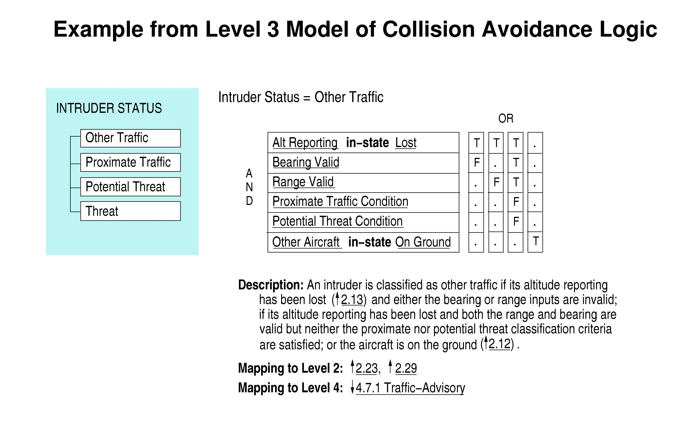
Figure 3 - Example of an AND/OR Table from our TCAS Level 3 Specification.

For TCAS, an important state variable is the status of other aircraft around the TCAS aircraft, called intruders. Intruders are classified into four groups: Other-Traffic, Proximate-Threat, Potential-Threat, and Threat. The figure shows the logic for classifying an intruder as other traffic using AND/OR tables. We are working on additional ways to visualize this information.

The rows of the tables represent AND relationships while the columns represent OR. The state variable takes the specified value (in this case, Other Traffic) if any of the columns evaluate to TRUE. A column evaluates to TRUE if all of the rows have the value specified for that row in the column. A dot in the table indicates that the value for the row is irrelevant. Underlined variables indicate hyperlinks. For example, clicking on Alt Reporting would show how the Alt Reporting variable is defined: In this version of TCAS, the altitude report for an aircraft is defined as Lost if no valid altitude report has been received in the past six seconds. Bearing Valid, Range Valid, Proximate Traffic Condition, and Proximate Threat Condition are macros, which simply means they are defined using separate logic tables. The additional logic for the macros could have been inserted here, but we have found that sometimes the logic gets too complex and it is easier for reviewers if, in those cases, the tables are broken up into smaller pieces. This decision is, of course, up to the creator of the tables.

The SpecTRM-RL models are executable and formally analyzable. Existing analysis tools include checking the logic specified in the AND/OR tables for logical consistency and completeness. Other tools are in the experimental or developmental stage, including tools to generate test cases directly from the tables.

Component Designers View: If a formal (rigorously defined) modeling language is used at Level 3, code may be able to be generated directly from the black box models and the information needed at this level will be reduced. If a hand implementation is done, then this level will contain the normal physical and logical design representations. The only difference will be the embedded hyperlinks.

Implementer and Manufacturing View: Level 5 will contain software code, engineering drawings for physical devices, hardware assembly or manufacturing instructions, etc., again with embedded hyperlinks to related information in other parts of the intent specification.

Operations View: Level 6 documents the interface between development and operations. It contains performance auditing procedures, operator manuals, training materials, error reports and change requests, etc. Again, hyperlinks are used to maintain traceability, particularly traceability to design rationale and safety-critical decisions and design constraints.

Conclusions

Intent specifications integrate the documentation of safety information into the engineering decision-making environment. They also facilitate the tracing of system-level requirements and safety constraints into design and the assurance of safety as well as other properties.

While intent specifications are helpful in organizing project development and reducing development time⎯by assisting in early validation of design decisions and thus reducing rework⎯their most important advantages will be reaped during system evolution and sustainment and in the reuse of components originally designed for other projects. They facilitate maintenance, troubleshooting, reuse, upgrades, operations, training, and the safety analyses needed to change the system without affecting risk.

We have enough industrial experience to know that using intent specifications is both possible and effective. For example, the third modeling level has been used by those maintaining TCAS for the past ten years to evaluate proposed TCAS changes before they are made. Each proposed change or upgrade is first made to the Level 3 SpecTRM-RL model to determine whether it is effective and safe before being given to the manufacturers of TCAS boxes to implement in their products. Intent specifications have also been used for a variety of government and commercial air traffic control, aerospace, and automotive systems.

References

1. Urban Kjellen. An evaluation of safety information systems at six medium-sized and large firms, Journal of Occupational Accidents, 3:273--288, 1982.

2. Nancy G. Leveson and Jon Damon Reese. URL: http://sunnyday.mit.edu/papers/intent.ps or
http://sunnyday.mit.edu/papers/intent.pdf

3. Nancy G. Leveson. Safeware: System Safety and Computers, Addison Wesley, 1995.

Biography

Prof. Nancy G. Leveson, Aeronautics and Astronautics Dept., MIT, Room 33-313, 77 Massachusetts Ave., Cambridge 02139, telephone – (617) 258-0505. facsimile – (617) 253-7397, email – Leveson@mit.edu.

Resolution advisories are escape maneuvers created by TCAS for the pilots to follow. Example resolution advisories are DESCEND; INCREASE RATE OF CLIMB TO 2500 FPM; DON'T DESCEND.

