A GRAPHICAL LANGUAGE FOR DESCRIBING COMPLEX SYSTEM BEHAVIOR: APPLICATIONS TO DESIGN, TRAINING AND USER OPERATION
Edward Bachelder, Nancy Leveson
Department of Aeronautics and Astronautics
Massachusetts Institute of Technology

1. Abstract
Operator manuals of complex systems involving human-machine interaction largely employ text to convey knowledge of the system. The occasional diagram intending to integrate portions of the text typically focuses on mechanical/electrical component interaction – a schematic of the automation logic is a rare finding. When the automation is diagrammed, it is usually presented as a stand-alone system that communicates only with itself: The communication between human and machine is often explained separately in tabular form, given as a listing of stimulus and associated meaning.
While such a piecewise presentation can impart eventual understanding of the system to an operator, hands-on training and operation is generally considered the primary means for building a mental model of how a system works. However, accidents abound where a major contributing factor was user disorientation/ misorientation with respect to the automation behavior, even when the operator was a seasoned user.
This paper will present a compact graphical method that can be used to describe system operation, where the system may be composed of interacting automation and/or human entities. The graphical approach is applied to an actual commercial aircraft system, using the descent flight phase as a testbed. Cockpit and flight management system manuals are used to construct the system model, whose fundamental goal is to capture and present critical interactive aspects of a complex system in an integrated, intuitive fashion. Potential applications of this model to design, training and user operation are presented, and various instances of potential mode confusion are identified in the commercial aircraft case study.

2. Introduction
One of the hopes placed in automation during its early years was emancipation – automation’s emancipation from the human. The last three decades are awash with designs intended for human-free operation, but later had to be rigged to allow human supervision and intervention [8]. An uneasy co-existence between software and wet-ware has reluctantly been accepted by most commercial designers, but the usual practice is to assign as many aspects of system operation to software and fill the remaining gaps with a human. This “software-centered” design created a new breed of accidents characterized by breakdowns in the interaction between operator and machine. Swinging in the opposite direction to remedy this has been “human-centered” design, where emphasis can be placed on artificial constraints that might arise from a user’s naïve mental model (i.e., fool-proofing) or from a designer’s model of the “one best way” [11]. Another emerging perspective treats human variability as a source of stability within an adaptive system instead of as erroneous behavior. Flach et. al [4] has termed this approach “use-centered” design, where it is assumed the human will naturally adapt to the functional constraints if those constraints are visible.
A key goal of the MIT Software Engineering Research Lab (SERL) is to create a methodology that will support integrated design of the automation and human tasks in complex, safety-critical systems. Such a methodology will not only address unsafe and problematic system features, but will be able to do so early in the design process when changes can still be made relatively easily. The methodology will be based on formal modeling, simulation, and analysis techniques starting with a user model of the system and generating appropriate and safe software and task models. The modeling tools should assist engineers and human factors experts in enhancing situation awareness, minimizing human errors such as those related to mode confusion, enhancing learnability, and simplifying the training of humans to interact with the automation.
A first step in achieving these goals is to determine how to use modeling and analysis to detect or prevent automation features that can create mode confusion. Three types of models are used: a user model, an operator task model, and a detailed specification of the blackbox automation behavior [7]. In this paper we describe the user model, which has shown to be helpful in detecting system features that can lead to mode confusion. This model appears to hold promise for use-centered design both as an analysis tool and as an onboard display concept. A specific case study employing the user model on an actual vertical flight control system is described. The goals of the case study were to show scalability and efficacy of the approach for complex systems.

3. Background
Leveson et al. has identified six categories of system design features that can contribute to mode confusion errors: ambiguous interfaces, inconsistent system behavior, indirect mode transitions, lack of appropriate feedback, operator authority limits, and unintended side effects [9]. One result of a case study by Leveson and Palmer [10] was a recognition that mode confusion errors could only be identified if the software (automation) model was augmented by a simple model of the controller’s view of the software’s behavior (a user’s model) - the formal software specification was not enough.
The work of Rodriguez et. al [12] investigated the utility of comparing user and pilot task models for detecting potential mode confusion in a MD-11 Flight Management System (FMS) case study. Building on this work, it was found that the analyst’s “situational awareness” of human/machine interplay improved if key aspects of the operator model were incorporated in the user model, thus producing a hybrid of the two. In this way accuracy, speed and focus are enhanced – comparing individual elements of two complex, structurally dissimilar models tends to be difficult and distracting.
Degani [3] developed a task-modeling framework, known as OFAN, which is based on the Statecharts language. Our experience in using Statecharts on real systems found it to be inadequate for our goals. Therefore, we have designed a blackbox automation requirements specification and modeling language call SpecTRM, which includes specification of modes and which we have found scales to large and complex systems [7]. The SpecTRM toolset is based on a methodology that supports human problem solving and enhances the safety and quality of systems, such as those that integrate human decision-making and automated information gathering. The SpecTRM tool set uses an approach for describing system specifications known as the Intent Specification.

Intent specifications are based on fundamental ideas in system theory and cognitive engineering. An intent specification not only records information about the system, but also provides specifications that support human problem solving and the tasks that humans must perform in system and software development and evolution. There are seven levels in an intent specification, each level supporting a different type of reasoning about the system. The information at each level includes emergent information about the level below and represents a different model of the same system. Figure 1 shows the overall structure.
Javaux uses a finite state machine to describe a cognitive mental model, which he uses to identify potential instances of mode confusion [5, 6]. We do not try to model human cognition or human mental models. Instead we model the blackbox behavior of the automation that the user expects and depends upon to perform the required steps needed to complete a given task. Modeling the actions involved in an operator task potentially allows analysis of the operator interaction along with a formal model of the rest of the system.
In his paper “Designing to Support Adaptation,” Rasmussen [11] states that an information system design should have content that faithfully represents the functional structure of the system, its operational state, and the boundaries of acceptable system operation. Many of these elements are contained in the model presented here, so that the user model conscripted for mode confusion analysis may actually offer itself as a valuable training and operator aid.

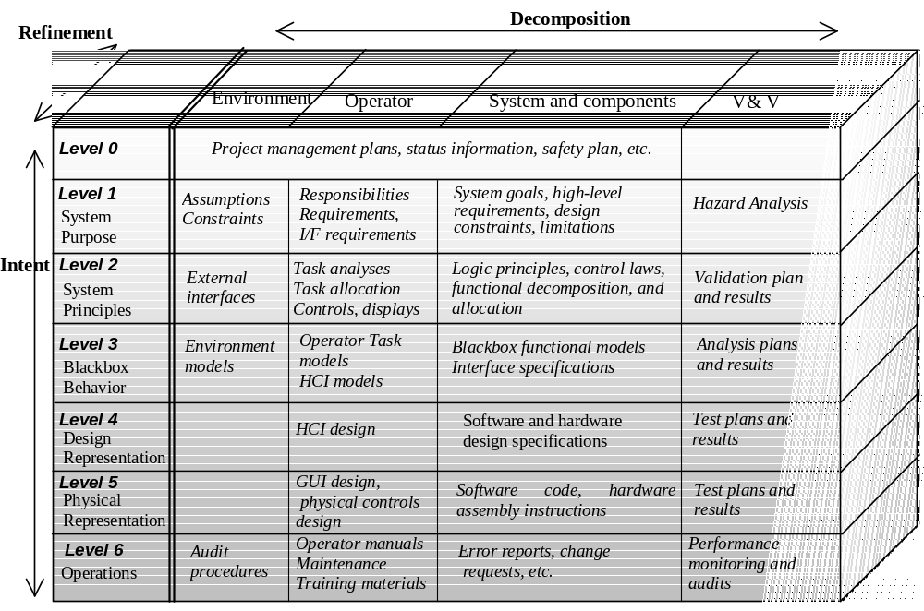
Figure 1 - Components of an intent specification.

4. Approach
A controller (automatic, human, or joint control) of a complex system must have a model of the general behavior of the controlled process. Feedback via sensors to the controller serves to update the model so that it can remain consistent with the actual process being controlled. When a human shares control with automation, the distinction between automation and the controlled process can become difficult to perceive (or irrelevant) from the user’s perspective. If an operator’s mental model diverges from the actual state of the controlled process/automation suite, erroneous control commands based on that incorrect model can lead to an accident [8]. Mismatches between model and process can occur when:
- The model does not adequately reflect the behavior of the controlled system.
- Feedback about the state of the modeled system is incorrect.
In order to specify and validate these models, a user model that incorporates elements of a human task model is used. For an existing system, this model can be extracted from the operator’s manual and other operator documentation and training materials for the given system. Ideally, the model would have preceded the built system so that the tasks, detailed automation specifications, and training and operator manuals will have been written from the user model.
The components of the graphical language, shown in Figure 2, refine on the set developed in [12] so as to better reflect information and process 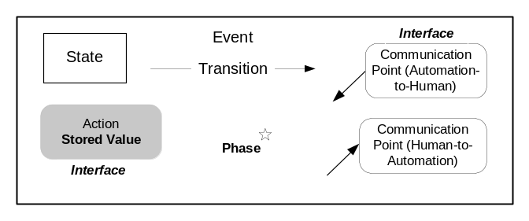Figure 2. Components of user modeling language
flow, as well as reduce diagram clutter. Steps required to complete a task are represented by states, which in this study consist simply of checking variables and waiting for changes to occur. A transition is defined as the process of changing from one state to another. Conditions that trigger transitions are called events and an action describes a result or output from the transition. A communication point links different actors together. A square box represents a state, a line with an arrowhead represents a transition from one state to the next, and events are shown in text above the transition. Actions are denoted by text with gray shade beneath the transition. Values and parameters associated with automation action that are pre-determined (stored) appear in bold, and the sources (interfaces) where these values and parameters are found are indicated above or below the action ovals in italics. Round boxes with down-arrows denote automation-to-human communication points, and italics above the communication point indicate the interface where that communication appears to the human. Similarly, up-arrows indicate communication from the human to the automation. Finally, a superscripted star indicates phase of automation or operation.

Case Study of a Vertical Flight Control System
In order to test the user model, we performed a case study on the vertical flight control system of an actual commercial airliner. The descent phase was selected for analysis because this phase has been associated with the most aircraft accidents and incidents. Figure 3 shows the user model that was created with the airliner’s Pilot Guide and FMS Guide. It should be noted that this model does not necessarily reflect the aircraft’s actual system operation; rather it is a graphical interpretation of the textual guides. Discrepancies or potential problems

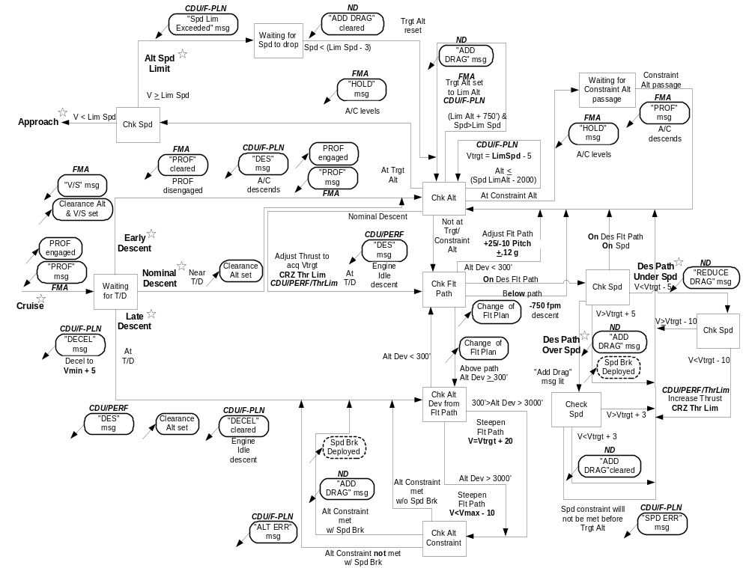
Figure 3. User model for FMS vertical descent

that are indicated by the model may be due to Pilot Guide inaccuracies (which is a real-world problem), or reflect actual system issues -- the authors’ interpretation of the manuals shall be considered unassailable, for now. Considerable effort was expended to capture compactly and clearly all the paths that the design (manuals) had intended to occur. The extent to which this is accomplished largely determines its utility as an analysis tool. Numerous iterations of crosschecking manuals with model were required before the model stabilized at its current form. This extensive time investment coupled with the uncertainty of manual accuracy are yet more reasons arguing for pre-design analysis emphasis, versus post-design.
Four of the six previously cited system features that can lead to mode confusion were found in this model and are presented in the following subsections. The four features are: indirect mode changes, inconsistent system behavior, ambiguous interfaces, and lack of appropriate feedback. A subsection then describes three scenarios where the system could behave unexpectedly due to one or more of the detected mode confusion features.

5.1 Ambiguous Interfaces
Interface mode errors can occur when the computer maps multiple conditions onto the same output and the operator interprets the interface erroneously. In Figure 4 two conditions taken from the user model (Figure 3) are shown: Altitude Speed Limit and Descent Path Overspeed. Referring to the Altitude Speed Limit condition, if the aircraft’s descent airspeed is greater than a preset Limit Speed and the altitude is less than 750 feet above a preset Limit Altitude, the Target Altitude is reset to the Limit Altitude and the message “ADD DRAG” is issued on the Navigation Display (ND). The Federal Aviation Administration (FAA) mandates that all aircraft below 10,000 feet fly at airspeeds less than 250 knots. The default values for the FMS Limit Altitude and Limit Speed are therefore 10,000 feet and 250 knots, respectively. If the Target Altitude is reached (in the above case, 750 feet after it has been reset to the Limit Altitude), the aircraft will automatically level and remain so until the airspeed has dropped to 3 knots below Limit Speed, at which point the descent resumes.
For the Descent Path Overspeed scenario in Figure 4, an “ADD DRAG” message is issued if the airspeed exceeds 5 knots over what is programmed into the flight plan. However, the automation will not take action (provided the speed does not approach Maximum Safe Speed). Unless the pilot crosschecks the “ADD DRAG” message with the Target Altitude (located on the Flight Mode Annunciator, FMA), he/she could think the aircraft is in Descent Path Overspeed mode when in fact it is in the other mode. In one case the aircraft’s flight path continues uninterrupted, while with the other a level-off occurs. It should be added that the Target Altitude on the FMA does not give an indication when it has reset to the Limit Altitude–-it simply changes numerical value, which decreases the likelihood of detection. Lastly, the Target Altitude and “ADD DRAG” messages appear on different displays, and the Limit Altitude is found several menu pages deep in the Flight Plan, located on the Central Display Unit (CDU).
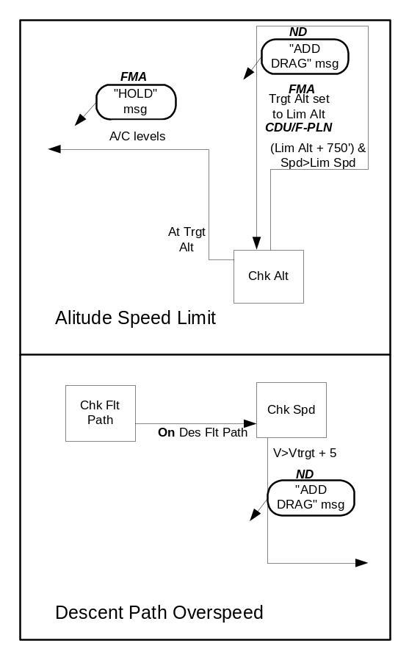
Figure 4. Ambiguous interfaces.

The model facilitates spotting this feature of mode confusion by indicating identical or near-identical messages for different conditions.

5.2 Indirect Mode Change
An indirect mode change occurs whenever there is a change in mode by the automation without explicit command from the operator. Five instances of this occur in the model. One of these is shown in Figure 4, where the Target Altitude automatically resets to the Limit Altitude when the aircraft is within 750 of the Limit Altitude. Two other instances are shown in Figure 5: 1) When the aircraft is within 2000 feet of the Limit Altitude, the Target Speed (Vtrgt) is automatically reset to the Limit Speed less 5 knots, and 2) Just prior to reaching the descent point (for nominal descent), the thrust will automatically be adjusted to acquire the profile Target Speed. In subsection 5.5 these seemingly unrelated transitions are linked yielding a potentially hazardous situation.
As with the Target Altitude, there is no indication when the Target Airspeed resets other than a change of the digits on the FMA (this also falls under the feature, “lack of appropriate feedback”). An especially useful feature of the user model is the ease with which indirect mode changes are recognized: one simply looks for the shaded action ovals that are not adjacent an up-arrow communication point.
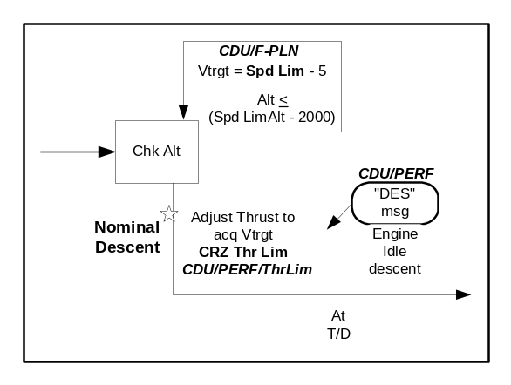
Figure 5. Indirect mode change.

5.3 Inconsistent System Behavior
Carroll and Olson define a consistent design as one where a similar task or goal is associated with similar or identical actions [2]. If during the descent a change is made to the flight plan that puts the aircraft above the desired flight path, the speed will be adjusted via pitch (engine idle descent) to regain the flight path. The flight manual only states that a return to path will be executed using 20 knots over the Target Airspeed if the vertical deviation from the flight is greater than 300 feet. However, in the glossary, one finds the value (Vmax – 10) associated with a return to path if the vertical deviation exceeds 3000 feet. Aside from extremely poor documentation, this also points to a highly discontinuous control scheme as well as an indirect mode change (Figure 6). If a pilot routinely encounters flight path deviations (due to changes of flight plan) of less than 3,000 feet, he/she will likely sit up when the airspeed starts climbing toward Vmax (even if the pilot at some point in past training was aware of this automation feature). The manual does not specify whether the speed strategy chosen by the automation is reflected in the Target Speed.
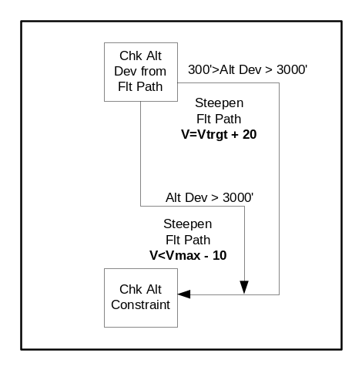
Figure 6. Inconsistent system behavior.

5.4 Lack of Appropriate Feedback
Most of the mode confusion instances discussed could be attributed indirectly or directly to feedback (mode or content). Figure 8, however, demonstrates a case of incorrect feedback that deserves special mention. The Late Descent procedure begins when the calculated descent point is overflown because clearance to descend has not been granted. At this time the aircraft slows to (Vmin + 5), a “DECEL” message appears on the CDU/Flight Plan menu page, and a “DESCENT” message appears on the CDU/Performance page – but the aircraft is still in level flight! When clearance to descend is later issued, the pilot dials in the clearance altitude, the “DECEL” message is cleared, and the aircraft begins idle descent. Why the “DESCENT” message doesn’t actually coincide with the maneuver itself is not addressed in the manual.
Again, the user model proves to be a valuable inspection tool for this kind of mode confusion by comparing automation action with feedback, i.e., looking for a down-arrow communication point (or interface) above an action oval. Lack of appropriate feedback can also be linked to feedback inaccessibility, an issue that the model addresses by clearly mapping the information source flow associated with messages, parameter resets, automation intentions, and automation limits of operation. The problem of information buried in pages of electronic menus is also highlighted through use of this model.
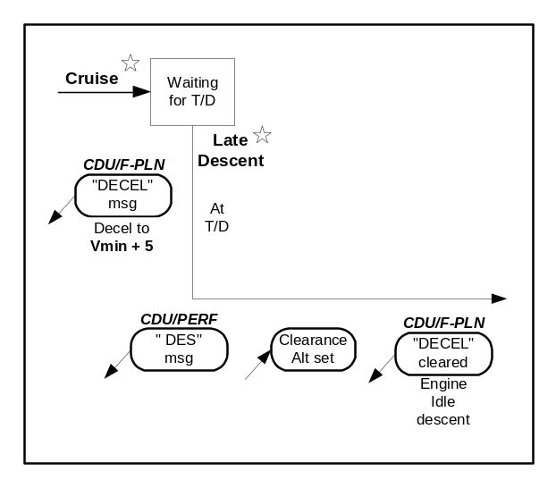
Figure 6. Inconsistent system behavior.

5.5 Example Scenarios Linking Mode Confusion to Potentially Hazardous Behavior
In this first scenario, an emergency condition is assumed to exist that warrants the aircraft fly at or below 220 knots (i.e. for controllability reasons). Also, assume a descent profile is being flown using the FMS where 220 knots is programmed into the flight plan. Referring to Figure 3, when the altitude is within 2,000 feet of the Limit Altitude (default set to 10,000 feet), the Target Speed will automatically be reset to 250 knots (Limit Speed) and the pitch lowered to acquire that speed – against expectations of the pilot.
It is possible that the flight computer logic is actually designed to “see” the lower of the two speeds (Limit Speed, Flight Plan Speed), but this is not specified in the manuals – hence it cannot be assumed. Such a scenario appears to an excellent candidate for investigation in a simulator if the manufacturer is unable to provide an answer. Of course, if this were the user model of a proposed design, the logic would be changed to ensure the lower of the two speeds was always selected.
In the second scenario, a change of flight plan leaves the aircraft more than 3,000 feet above the desired flight path, and the aircraft accelerates toward (Vmax – 10) knots as per Figure 3. Passing through 12,000 feet (2,000 feet above Limit Altitude), the aircraft is still over 3,000 feet above the flight path. The manual doesn’t indicate if at this point the Target Speed is reset to 245 knots (Limit Speed – 5) or if (Vmax – 10) is maintained. If (Vmax – 10) is maintained, then at 10,750 feet (Limit Altitude + 750) the Target Altitude is reset to 10,000 feet and a level-off is initiated. Because of the normal force (g’s) limits within the control logic, this recovery would likely result in the aircraft “busting” the 10,000 foot ceiling at over 250 knots. If at 12,000 feet the Target Speed resets to 245 knots, the aircraft flight path would nearly flatten out during the deceleration. Both of these situations could catch the pilot and/or air traffic controller by surprise. Once again, testing this scenario in a simulator would seem worthwhile barring an answer from the manufacturer.
The last scenario involves the early descent phase shown in Figure 3. Because the pilot is expecting to execute a nominal descent the “PROF” mode was engaged during cruise. Upon receiving early clearance to descend he/she enters the clearance altitude on the Flight Control Panel and selects a vertical speed. Both of these actions disengage “PROF” mode and the “PROF” message extinguishes. The pilot’s intention is to immediately re-engage “PROF” so that when the target/constraint altitude or desired flight path is reached (whichever comes first) the flight plan is resumed. A minor cockpit emergency requires immediate attention, however, before “PROF” can be re-engaged. After the emergency has been dispatched the pilot scans the displays and sees that the aircraft is approaching flight path at a comfortable rate. The co-pilot is then given the controls while the pilot follows up on the emergency, looking for secondary indications. Five minutes later the co-pilot informs the pilot that the FMS failed to pick up the planned flight path, flying through it instead.
One of the insidious aspects of mode changes in cockpits is that they are sometimes indicated via a lit message going dark. As will be discussed in the following section, an important part of feedback is not only displaying the current state, but what state the automation is likely progressing toward – and what state the automation most recently departed. A quick solution to the problem just presented could have the “PROF” message switch from amber (on) to another color (indicating recently turned off) that stays illuminated for a limited time (i.e., one minute) following disengagement. A deeper solution is discussed in the next section.

6. Implications
From a designer’s view, the user model presented in this paper should enhance the capability to iteratively develop numerous levels of the intent specification (Figure 1). Specifically, these levels would be 1, 2, 3, 4 and 6. By visually mapping processes that: 1) are continually crosschecked with intent specifications, and 2) follow a concise mapping methodology, the system design and analysis procedure is far more likely to be contained, streamlined, and tractable than if piecewise ideas simply spawn piecewise code. Projects that span time and/or multiple designers stand particularly to benefit from using this design methodology.
Three major areas of opportunity arise in the training domain where the model can improve on current practice: 1) writing operational manuals, 2) accelerating and broadening student system knowledge, and 3) revising safety procedures. By delineating both the automation and the controlled process “for all to see,” a far richer environment is created for ideas to be generated and expressed between instructors, students, and safety departments. It has been argued that in order to limit the size of operating manuals, just enough information is given for routine tasks and the most-likely emergencies to be handled---beyond this the operator is expected to learn from simulator and operational experience. The counterargument to this is that user models applied to a design could allow an operator to absorb far more detail and complexity than what is currently given, leaving less to luck – good and bad. There could be varying levels of detail available to student operators (manuals could be placed on CD’s, for instance), where the capability exists to zoom-in on ‘complexity.’ This would also tend to force rigor on the part of the manufacturers and manual drafters.
Wood states that “updating and calibrating our awareness of the potential paths (to failure) is essential for avoiding failures because we are only partially aware of these paths, and, since the world is constantly changing, the paths are changing. The effort to escape or avoid stale, limited views of the changing potential for failure is one portion of the process of building a safety culture” [13]. When humans play a role in an automated process, they should be given the means to grasp the process in a way that stimulates the imagination. Visual stimulus and visual recall are often indistinguishable in terms of brain response – we love to watch things move forward. Why are we (most of us) inexorably drawn to the mocking progress-bar during a file download? Why is “a rat in a maze” still in our speech long after the experiment? And what about Pac-Man?
Referring to the operation of a work system, Rasumussen states that its “quantitative variables and the relational structure governing their interaction must be converted at the interface to a set of symbolic objects interacting through events in a virtual environment. The interface should therefore present a map of a symbolic landscape inhabited by objects – icons – representing states of processes, interacting mutually and with boundaries around territories of varying operational significance. This is important, not only to support the reasoning by an individual user, but also to give cooperating users an opportunity to point at and to discuss an external model” [11]. Voila! The medium is the analysis. Presenting a user with a model similar in concept to the one developed here would satisfy most of the functional requirements that Rasmussen cites a display should have. A method to enhance the perception of causality (and interest) could be to light that portion of the model’s path that is active, and by utilizing display persistence (varied as a function of path progression speed) a trail of decaying light would indicate path history. Based on vehicle-state trends and automation intentions, a future path could be indicated with a differently lit color. When a future conflict between automation intentions and the vehicle trends is predicted, the intended future path could flash and the variables of concern displayed. This also partly satisfies the requirement for representing the boundaries of acceptable system operation. In addition, actual quantitative limits of the automation could replace the name of the interface that currently points to those limits in the model.
In this case study four of the possible six sources of potential mode confusion were indicated by the user model. In another case study [1] involving a helicopter hydraulic leak detection system, the same type of user model indicated a fifth mode confusion source: unintended side effects. Potentially debilitating flaws were discovered in the leak detection system design, as well as with the prescribed emergency procedures associated with a hydraulic leak. A revision to the emergency procedures was consequently devised that reduced pilot vulnerability to catastrophic leakage.
Detection of the sixth source (operator limits) should be facilitated through use of the model, since the limits imposed by the automation are clearly indicated in relation to events and states, rather than in the usual tabular form that appears in manuals.
The vertical descent logic of this airliner case study can generally be described as ‘complex.’ However, ‘complexity’ is a vague expression, much as the term ‘workload’ is. A poor Operator Manual can turn a relatively simple system into a labyrinthine one, from the user’s standpoint. The extent that system operation requires knowledge, rule, and skill-based behavior must certainly influence how ‘difficult’ the system is to operate under normal and unusual conditions. It might therefore be said that certain metrics may reveal a system’s inherent operational difficulty. Depending on the user model imparted to operators, and of course the interface employed, the system’s complexity may increase from this baseline measure, and/or be partially perceived in a way that could increase the likelihood of an accident.

How the mix of cognitive control (knowledge, rule and skill) actually affects complexity is a vast, unexplored topic. A crude measure of system difficulty may be the number and proportion of components in a user model, but the actual utility of such a measure is not clear.
A key goal of the model proposed in this paper is to strip away some of the artificial complexity often found in manuals to allow a clearer view of the operator/machine dynamics and potential pitfalls.

7. Conclusions
A graphical language has been developed whose concept seems to suggest itself as a natural “fit” to many levels of design and training. The elements of the language are still preliminary, and its actual merits must be borne out by experimentation. However, the model proved to be particularly illuminating when employed on a complex automated system. An unexpected realization while developing the model as an analysis tool was its potential for use as an operator display.
Such a display is not proposed as a replacement for the current cueing system that exists on aircraft, as these cues serve an important function in rule-based action (cue-action responses). Rather, the user model display would support knowledge-based reasoning and mental experimentation – features that are gaping holes in the modern cockpit.

8. References
[1] Bachelder, E. and Leveson, N., (In Press), Describing and Probing Complex System Behavior: a Graphical Approach, SAE Aviation Safety Conference, Sep 10-14, Seattle, WA

[2] Carroll, J.M. and Olson, J.R., 1988, Mental Models in Human-Computer Interaction, in M.Helander (Ed). Handbook of Human-Computer Interaction, Elsevier Science Publishers, pp. 45-65.

[3] Degani, A., 1994, Modeling Human-Machine Errors: on Modes, Errors and Patterns of Interaction, Ph.D. Thesis, Atlanta, GA: Georgia Institute of Technology.

[4] Flach, J.M. & Dominguez, C.O., 1995, Use-centered design, Ergonomics in Design, July 19.

[5] Javaux, D., 1998, An Algorithmic Method for Predicting Pilot-Mode Interaction Difficulties, 17th Digital Avionics and Systems Conference, Oct 31, Bellevue, WA.

[6] Javaux, D. and De Keyser, V., 1998, The cognitive complexity of Pilot-Mode Interaction, in G. Boy & C. Graeber (eds.), Proceedings of the International Conference on Human-Computer Interaction in Aeronautics, May 27, Montreal, Canada.

[7] Leveson, N., 2000, Completeness in Formal Specification Language Design for Process Control Systems, Proceedings of Formal Methods in Software Practice.

[8] Leveson, N., 1995, Safeware: System Safety and Computers, Addison-Wesley, New York.

[9] Leveson, N. 1997, Analyzing Software Specifications for Mode Confusion Potential, presented at the Workshop on Human Error and System Development, Glasgow, March.

[10] Leveson, N. and Palmer, E. (NASA Ames Research Center), 1997, Designing Automation to Reduce Operator Errors, in the Proceedings of Systems, Man, and Cybernetics Conference, October.

[11] Rasmussen, J., Designing to Support Adaptation, Hurecon, Denmark.

[12] Rodriguez, M. et. al, 2000, Identifying Mode Confusion Potential in Software Design, Digital Aviation Systems Conference, October.

[13] Woods, D. and Shattuck, L., (In Press) Distant Supervision – Local Action Given the Potential for Surprise, Cognition, Technology and Work.

