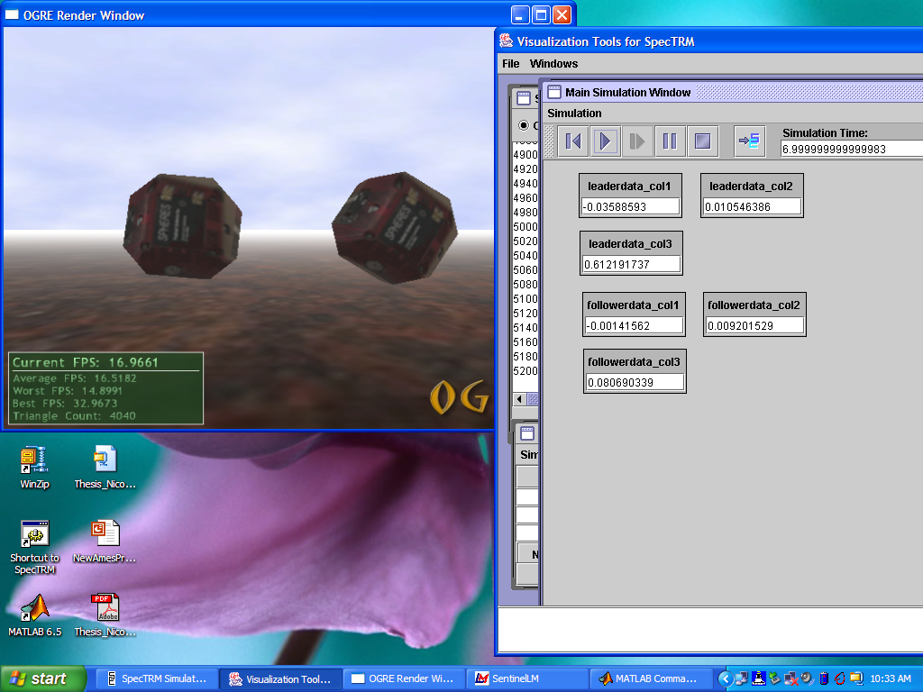

Simulating the behavior of SPHERES (formation-flying nanosatellites) using a SpecTRM-RL model of the control logic.
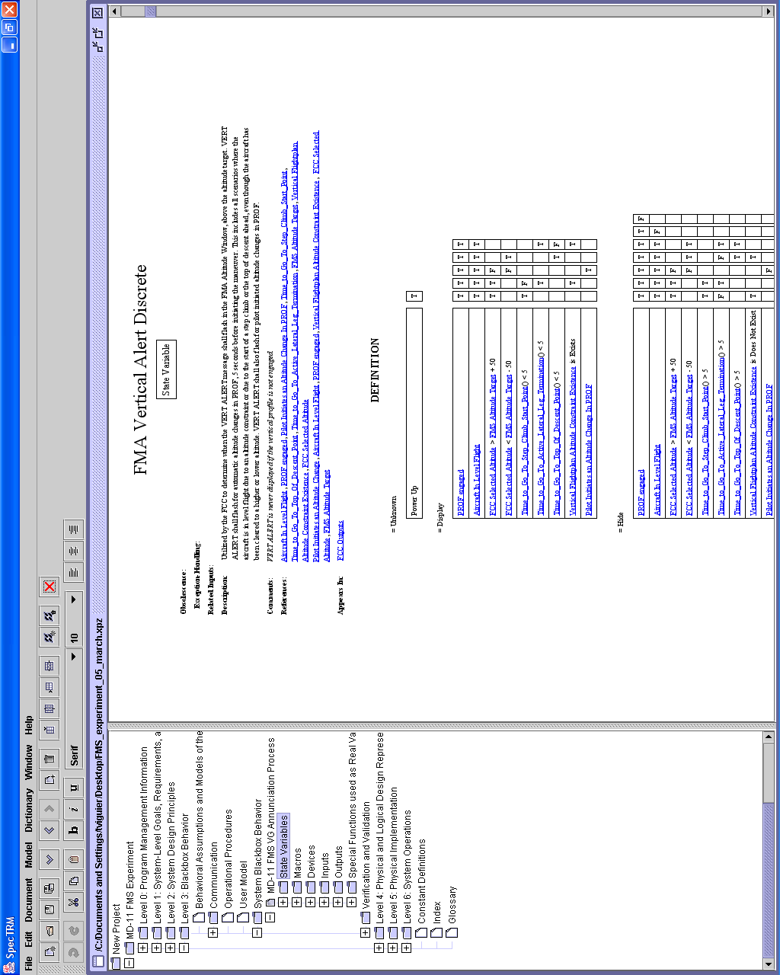 | Figure A: Screen capture of the SpecTRM GUI.

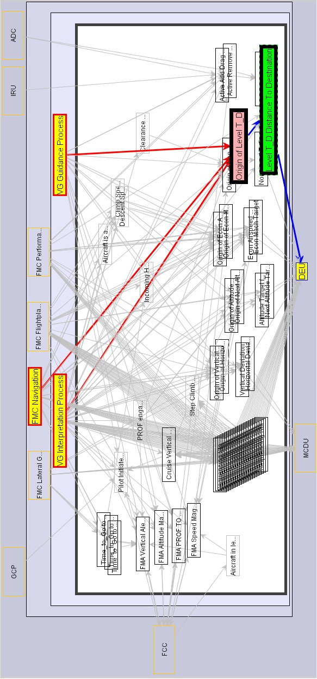 | Figure C: Sliced structural overview. The state variable Origin of Level T_D and its structural dependencies are emphasized over the rest of the model, which is preserved as context.
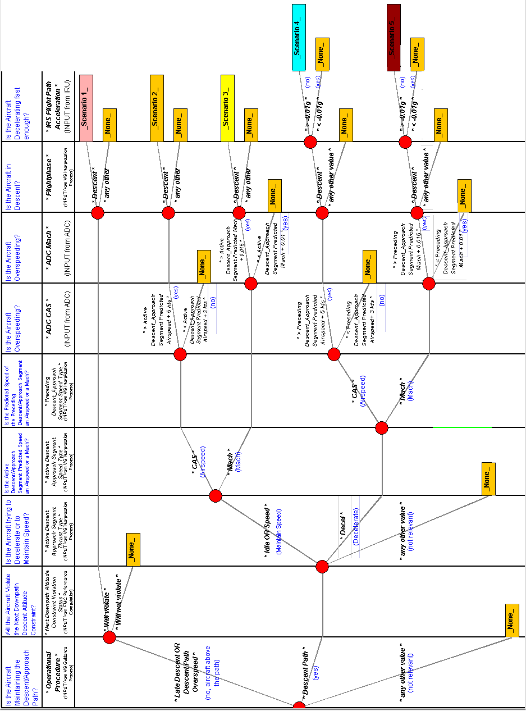 |  | Figure D: A Questions-based Decision Tree taken from the MD-11 Vertical Guidance Specification. The state variable Active Add Drag Scenario indicates which of the five possible scenarios for extending airbrakes is active, if any.

